Video script

1. CFDD – CTC logo slide

aud 1new - Hello , I am Neil Degrasse Tyson and today I will talk about *Development of Solutions for Smart Factory using Machine Learning Algorithms*

aud1.1 - they pay me no money so me talki like robot (LOL!!!!)

1. Problem

*<Insert Picture of marcelling lady and machine/robot on factory floor>*

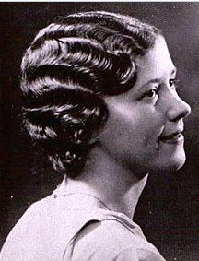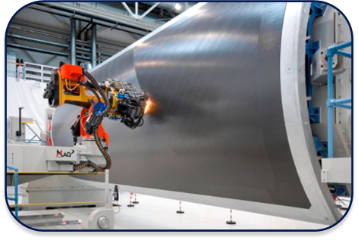

* 1. aud2 - Marcelled hair was a rage among women in the 1920s. It is a [hair styling](https://en.wikipedia.org/wiki/Hair_styling) technique in which hot [curling tongs](https://en.wikipedia.org/wiki/Curling_tongs) are used to induce a curl into the hair.
  2. aud3 - But what has this got to do with a company that deals with composite material?

aud4 - Well, it turns out that such a wave like pattern caused during the layering carbon sheets is highly undesirable when manufacturing airplane parts.

* 1. aud5new- So, with the help of the guidance received from CTC, and a LOT of discussion and brainstorming, they have designed the <drum roll>

CFDD…(aud6- carbon fibre discrepancy detector) !!!!!.

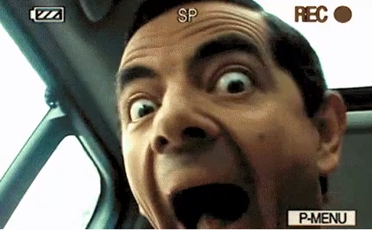

1. Solution: Part 1
   1. aud7 - It is a Real-Time Object Identification using Machine Learning algorithms, and Machine to machine communication for Quality and Progress Detection
   2. aud8 - And, here’s how they did it!
   3. aud9 - They started off by training the “Jetson Nano” to identify a defect using a super cool machine learning algorithm called YOLO .

aud10 - This meant iterating through a set of hundreds of test images in various positions and lighting conditions and creating bounding boxes around a potential defect.

aud 11 - In the end, they managed to obtain results with a good precision <insert video> or similar illustration

1. Solution part 2:

aud12 - Moving on to the second part of this project

* 1. aud13 - In order to make this data usable, we used an open source communication protocol called OPC UA to retrieve and display the time and image of the defect on a dashboard. Additionally, we also store the values in a database for reference.
     + - 1. <insert dash server image> or similar illustration
  2. aud14 - And that’s how we were able to convert a previously manual process into a scalable solution.

1. Part 3:
   1. aud15 - Apart from this, the team also worked on a novel concept called Image Inpainting and extended the same for video inpainting

<add an image that says “Part 3 - Image and Video inpainting”along with the image below>

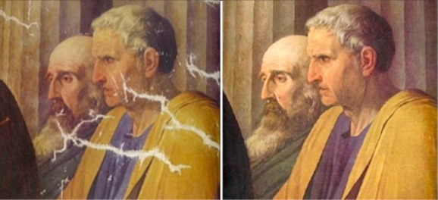

aud16 - Image inpainting refers to the process of filling-in missing data in an image.

aud17 - In this project the task was to remove a person from an image using image inpainting

<add the following image>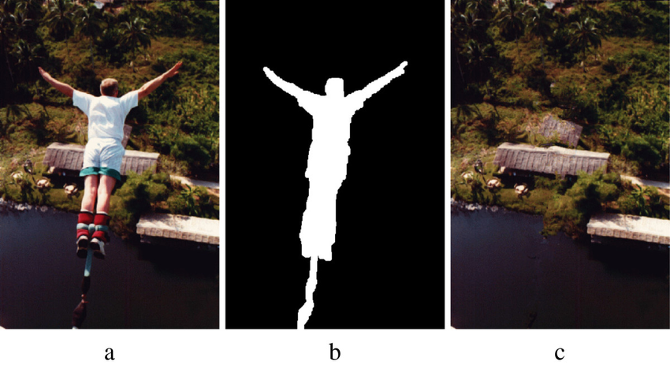

aud18 - The team compared one conventional approach and 2 machine learning based approaches for image and video inpainting. Since, video is just a series of frames or images, same algorithms can be extended to videos

<I will provide you the image for this>

aud19 - In conclusion, although conventional approach was somewhat able to fulfill the task with lesser computational demand, Generative Adversarial Network based approach did much effective inpainting, but required a lot of computational power.

aud20- You must be wondering whom i am referring to as ‘they’...

I would like to pass on to the team to introduce themselves and share their experiences with this program

* 1. Meet the team
     + 1. <insert videos of each of us introducing ourselves>
  2. Final credits and thankyou ( CTC and FFE)